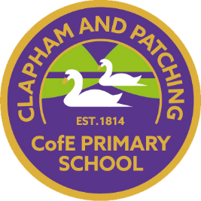
Clapham and Patching C of E Primary school

Children’s Climate Action Plan
✨ This plan puts children at the centre — not just learning about climate change, but leading positive action.
The actions will be led by Eco-club in consultation with the school council.

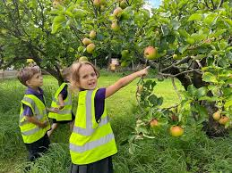
1. Food
What we are doing already:
- Growing fruit, vegetables, and orchard produce.
- Teaching about food waste and food miles.
What children will help with:
- Growing more food for use in school meals.
- Starting composting for fruit and veg waste.
- Reducing food waste at lunch (e.g., “waste-free lunches”).
- Checking food packaging for palm oil and talking about why it matters.
- Sharing leftover garden produce with families.

2. Transport
What we are doing already:
- Bikeability training for Year 6.
- Encouraging families to park at the village hall and walk in.
What children will help with:
- Joining or leading a walking bus from the village hall.
- Reminding parents not to idle engines outside school.
- Taking part in assemblies about the benefits of walking, cycling, and car-sharing.
- Learning more about how different types of transport affect climate change.

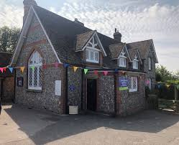
3. Buildings 🏫
What we are doing already:
- Refurbished old windows.
- Regular maintenance.
- Lots of indoor plants.
What children will help with:
- Checking windows and doors for draughts.
- Looking after classroom plants and adding more.
- Designing climate-friendly posters and displays around school.
- Sharing ideas for keeping warm/cool without wasting energy.
- Helping to create a “green wall” as part of the Wildings Project.

4. Water 💧
What we are doing already:
- Collecting rainwater in water butts.
- Using push-taps to save water.
- Learning about the water cycle.
What children will help with:
- Checking taps for leaks and reporting them.
- Reminding everyone to turn taps off quickly.
- Learning about floods and how to stay safe.
- Leading a water-saving campaign for families through posters or newsletters.
- Exploring how we might use water differently in the future.

5. Energy ⚡
What we are doing already:
- Energy-efficient boiler maintained and serviced.
- Using ECO modes on appliances.
- Monitoring energy use.
What children will help with:
- Switching off lights, screens, and equipment when not in use (“Switch Off Squad”).
- Putting up reminder signs near switches.
- Helping staff monitor classroom heating and cooling.
- Learning about renewable energy sources and sharing ideas for the future.
- Taking part in green energy challenges and competitions.

6. Consumption ♻️
What we are doing already:
- Avoiding single-use plastics.
- Using second-hand items and mending where possible.
- Recycling paper, glass, metal, and plastic.
- Running uniform swaps and community reuse.
What children will help with:
- Collecting items for recycling (batteries, pens, small electronics).
- Leading “make do and mend” activities (e.g., repairing toys, costumes).
- Talking to families about buying FSC-certified and eco-friendly products.
- Creating posters to encourage sustainable choices at home and school.
- Learning about how things are made and their impact on the environment.

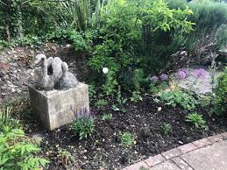
7. Grounds 🌳
What we are doing already:
- Lots of trees, plants, and rewilding areas.
- Outdoor learning and natural play spaces.
- Part of the Wildings Project.
What children will help with:
- Planting more trees and looking after them.
- Taking part in rewilding and soil-care projects.
- Growing food and flowers in outdoor learning areas.
- Using the outdoor classroom and wild spaces for lessons.
- Running tours or events for families to show what we’re doing for nature.
- Joining community tree-planting days.

🌟 Next Steps
- Eco Team will lead on checking progress and sharing updates in assemblies.
- Each class will choose at least one action per term to focus on (e.g., waste-free lunch, switch-off challenge, tree planting).
- We will celebrate achievements with the whole school community and keep adding new ideas.

